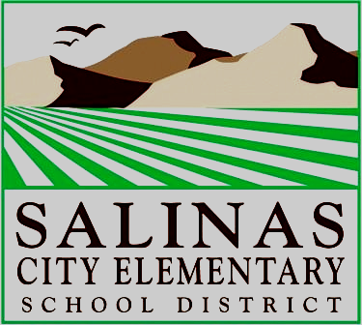
Salinas City Elementary School District Instructional Technology
Technology Use Agreement School Year __________

Please read this document carefully.
Terms and Conditions of This Agreement
The use of the assigned equipment must be in support of education and the educational goals and objectives of the Salinas City Elementary School District.
A. The technology equipment is to be used primarily for school work or furthering the employee’s technology skills.
B. The employee is responsible for the security and safety of the equipment. If the equipment or software is lost or damaged while offsite, the employee may be responsible for replacement. Please notify I.T. Dept. with the Police Report number, if the theft occurred.
C. Employees are required to have a SCESD AUP Internet User Agreement on file with H.R. and follow its restrictions while using the provided equipment, even at home. Employees are also required to follow the district’s policy on software copyrights.
D. The technology equipment must be returned upon the request of the District, unless the employee transfers away from Salinas City Elementary School District, terminates employment with the district, or goes on leave. In that case, the equipment must be returned immediately.
E. In any case, the equipment must be returned immediately upon the request of the district or the I.T. Director.

Name: |  | Position:
School: |  | Date

Check all that apply | Qty | Description | Condition | District ID# (asset tag)
🀆
🀆
🀆
🀆

Additional Equipment: No ID# on items; i.e. power cord, USB cable, HDMI cable, etc...
Power cable for

I agree to follow the rules contained in this agreement. I agree to return the technology equipment upon request of the district.
Employee Signature |  | Date

Issued/Delivered by: |  | Date:

CC: SCAN/EMAIL TO <itservices@salinascity.k12.ca.us> (for inventory count), Site Administrator, Employee

